//descargar driver internet explorer

<https://www.seleniumhq.org/download/>

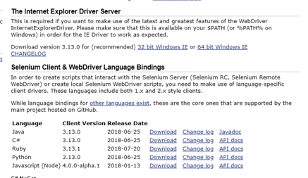

Today we will learn

1. How to add IE Driver

2. Run a test on IE browser

Step 1 :

Download IEDriver

Step 2 :

Add IEDriver in Eclipse

Step 3 :

Add script in Eclipse (IDE)

System.setProperty("webdriver.ie.driver",”location of iedriver”);

Webdriver driver = new InternetExplorerDriver();

Step 4 :

Run and Validate

String dirección=System.getproper(user.dir)

Always check the latest version of ie driver from

https://github.com/SeleniumHQ/seleniu...

If you give the location of folder having driver in environment variable Path, then you don’t have to set

System.setProperty("webdriver.ie.driver",”location of iedriver”);

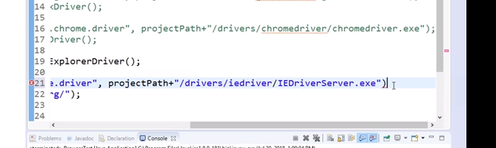

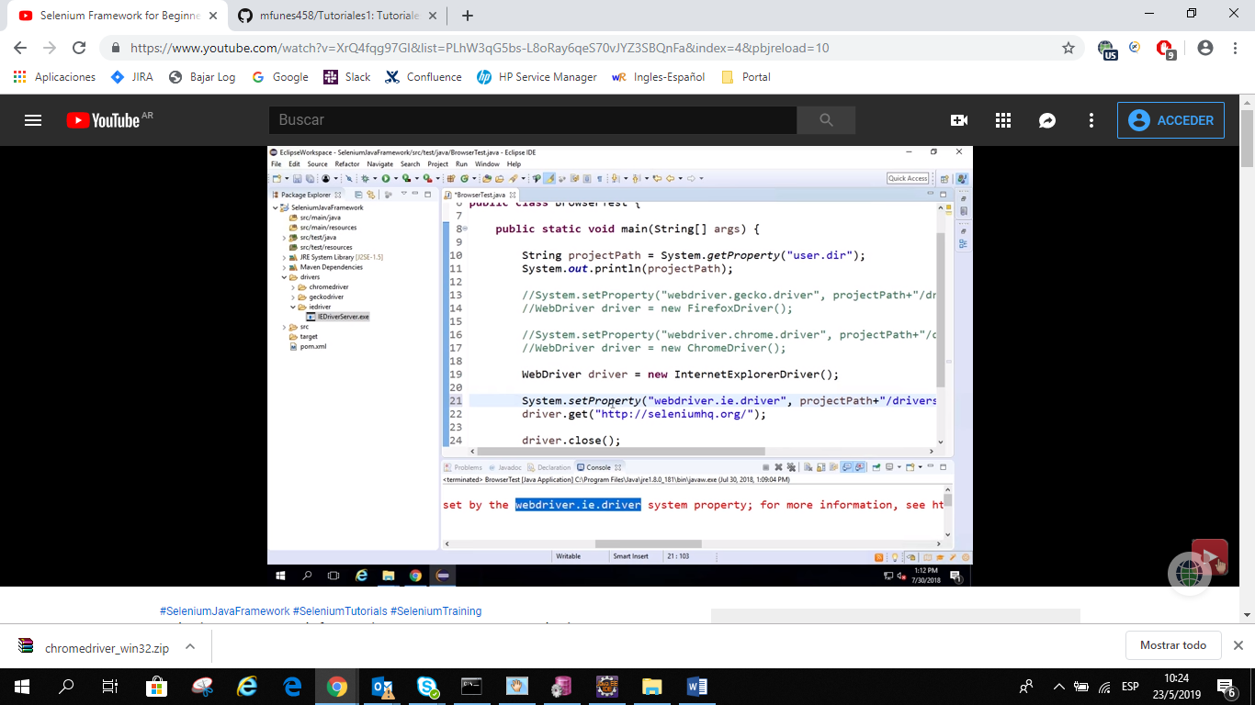

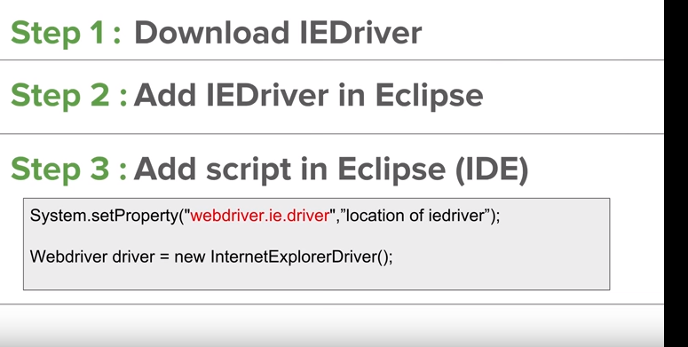

Configurar nevegador-option –security en todas las pestañanas destildar enable protect –aplicar-ok

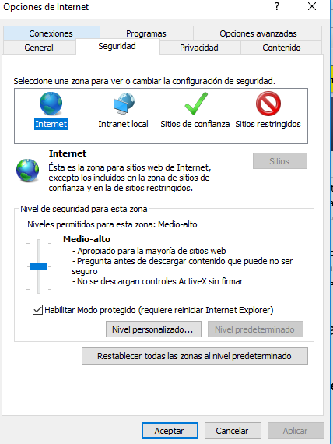

# Codigo

Verificar versión internetExplorer

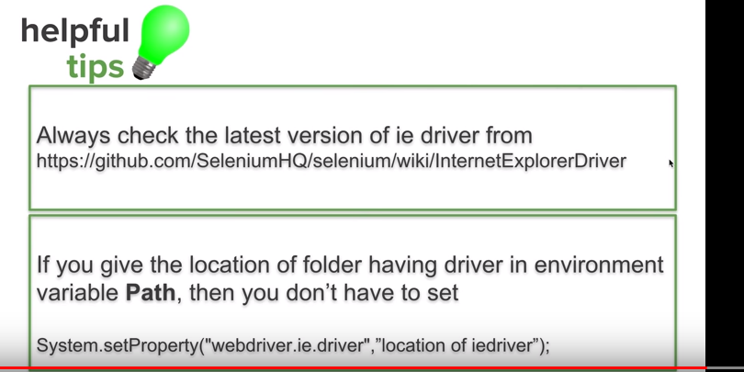

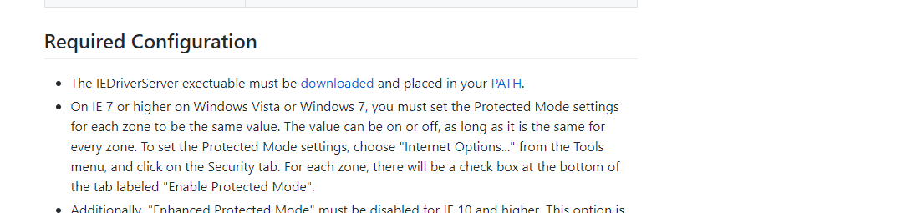

<https://github.com/SeleniumHQ/selenium/wiki/InternetExplorerDriver>

<https://selenium-release.storage.googleapis.com/index.html>

Se puede crear la variable de entorno (hasta la carpeta sin \)